**Demo Introduction**

**Keywords:**

Oracle Integration Cloud Service, Oracle Storage Cloud Service

**Goal of Demo:**

To demonstrate how easily to leverage Oracle Integration Cloud Service to build integration to pull Twitter feeds which the user cares about and store the data into Data Lake in Oracle Storage Cloud.

**Pre-requisites:**

User has registered both Oracle Integration Cloud Service and Oracle Storage Cloud Service. The storage containers for the demo have been configured properly.

User already has a Twitter account.

**Demo Steps**

**Step 1: Create an Application in Twitter**

This step will create an application in Twitter. However it is actually not an application running in Twitter. Instead it is for allocating OAuth 1.0 credentials for an remote application which can request Twitter services, for example retrieving feeds, creating Twitter message etc.

To create an application in Twitter, open a browser and access Twitter Application Management System with the URL: <https://apps.twitter.com/>. After a successful login with your Twitter account, you will see following Application Management page:

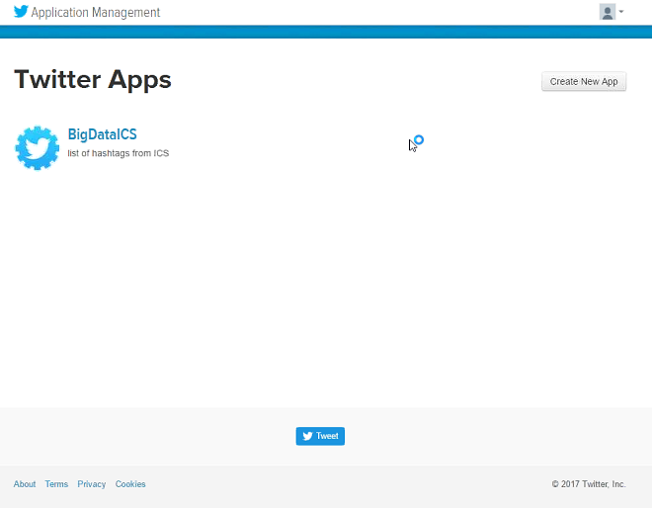

Click **Create New App** button to load the page below to create a new application.

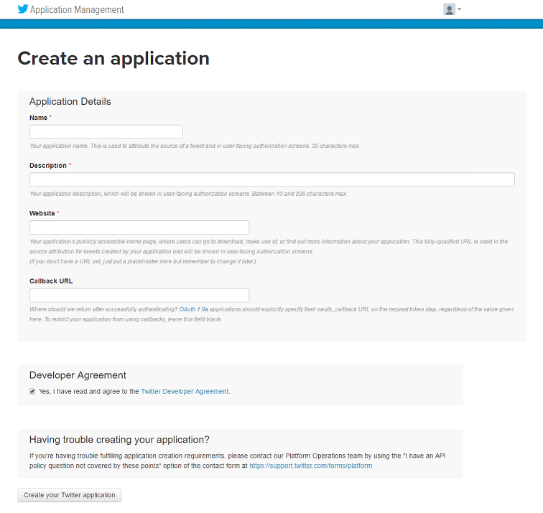

**Name** of the application must be unique among all users in Twitter. You’d better adding a user-specific prefix to the name. **Website** of the application must start with a protocol, either http or https in the demo. **Callback URL** is only necessary if the application need to request Twitter services as some other accounts. In the Oracle Integration Cloud Service, it only allows to use same account, so can leave the field empty.

After reading and accepting Twitter Developer Agreement, click **Create your Twitter application** button at bottom.

When the application is created, following application page will appear. You can review general information of the application. But the most critical information we need in the Oracle Integration Cloud Service is OAuth 1.0 credentials.

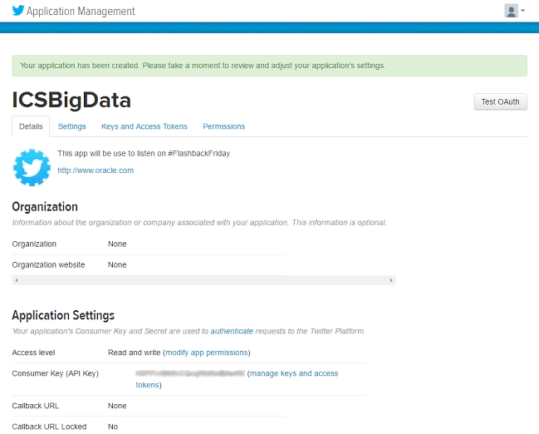

Select **Keys and Access Tokens** tab in the page. By default, only Consumer Key & Secret are generated. In this demo, we also need to allocate Access Token to access Twitter service from application.

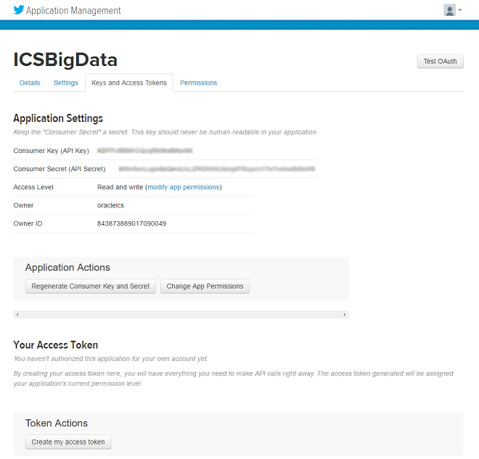

Select **Keys and Access Tokens** tab in the page. By default, only Consumer Key & Secret are generated. In this demo, we also need to allocate Access Token to access Twitter service from application. Click **Create my access token** button in Token Actions section to generate required credentials.

Keep Consumer Key/Secret and Access Token/Secret pairs confidentially for configuring connections to Twitter with Oracle Cloud Integration Service.

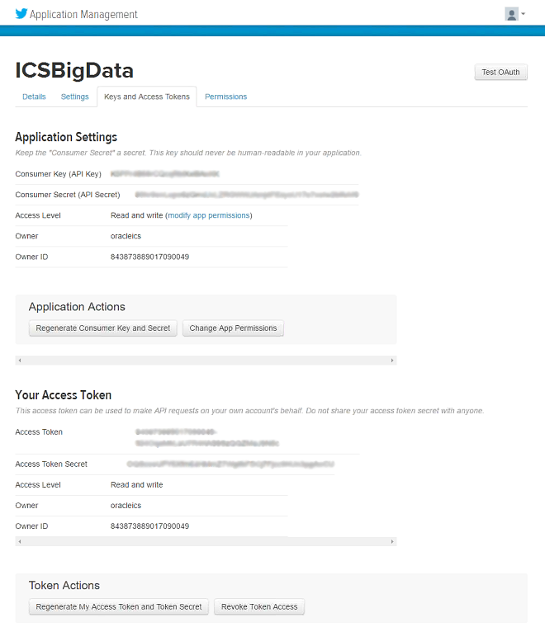

**Step 2: Configure Connections in Oracle Integration Cloud Service**

Oracle Integration Cloud Service can leverage built-in adapters to connect various kinds of external services. In this step, we will configure connections to Twitter and Oracle Storage Cloud Services.

You need to first login to Oracle Cloud to configure Oracle Integration Cloud Service. Open a browser, and then enter the URL of Oracle Cloud. Click **Sign In** link on the top to access following page:

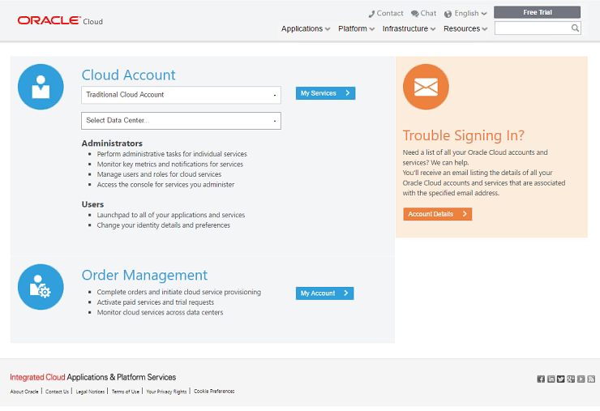

Oracle Cloud will leverage data center infrastructure in different spots across the world. After registering to Oracle Cloud, customers can request services from the data center near their location to get better performance.

When login to Oracle Cloud, customers need to first select the data center where their services have been deployed.

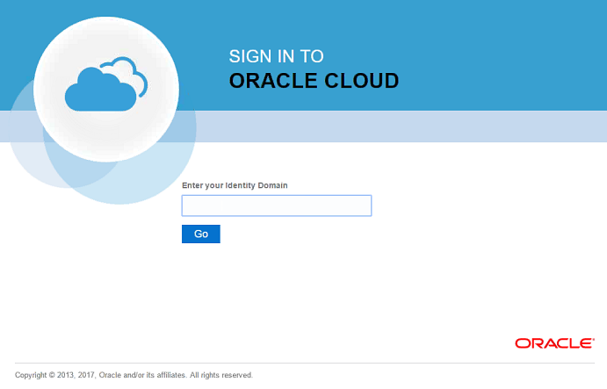

Identity Domain is the container where accounts and Cloud Services are provisioned. Customers must select the correct Identity Domain to login and access their services. In this demo, user should select the Identity Domain where Oracle Integration Service is provisioned.

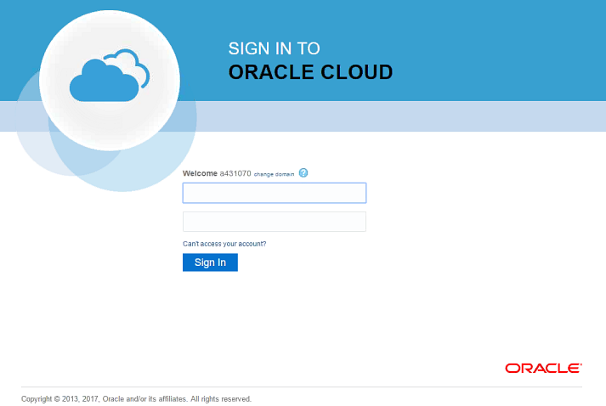

Then, credential information need to input to login to Oracle Cloud platform. After login to Oracle Cloud, user can view and access cloud services from following page.

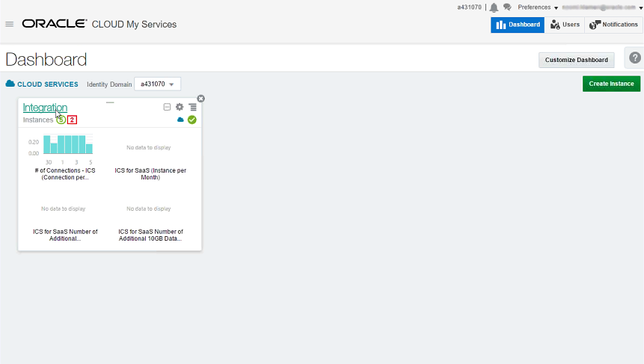

Select **Integration** catalog in this page to jump to following Oracle Integration Service page. From the **Overview** page, user can view current instances of Oracle Integration Cloud Service. Integrations are configured and deployed in separate service instances.

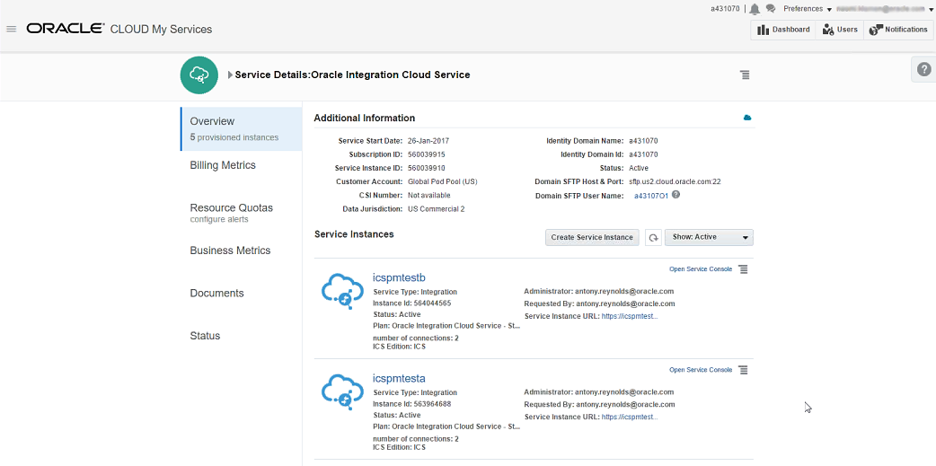

Click **Open Service Console** link of the service instance where connections and integrations will be configured. Integration Service Console will display as below:

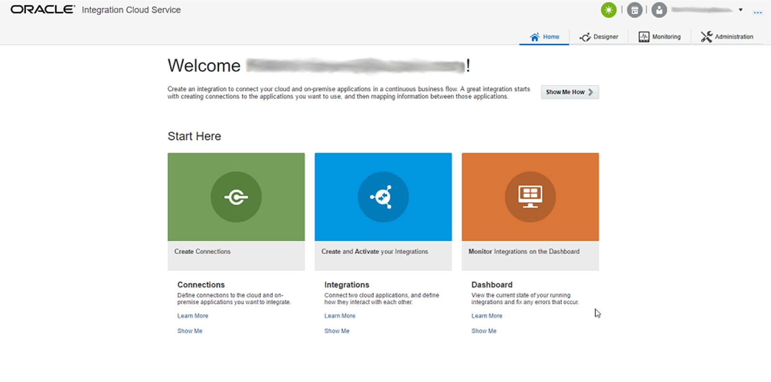

**2.1 Configure connection to Twitter**

Click **Create Connections** in the Console to load the Connection Designer page:

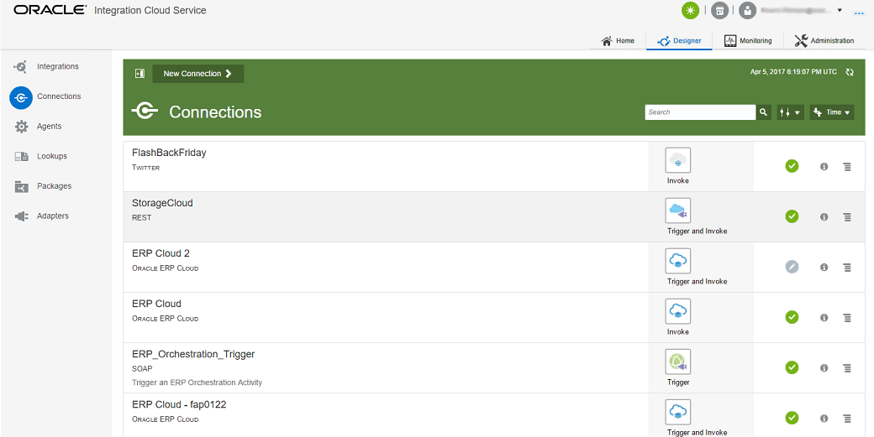

Click **New Connection** action in the page, following Wizard will appear to let you first select from pre-built adapters.

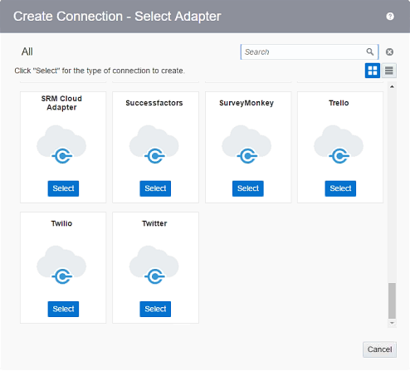

Scroll down to the bottom of the list you can find **Twitter** adapter, click **Select** button to confirm your selection. A Twitter connection configuration page will appear, first following dialog will pop up to input general information of the connection.

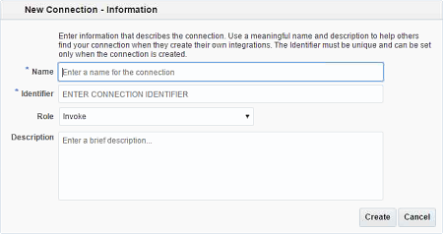

Specify a name of the connection, and select the **Role** to **Invoke** to allow request services to Twitter. Click **Create** button to create the connection.

After the connection is successfully created, you can see a light-green banner on top of the page. Next you need to configure parameters of the connection.

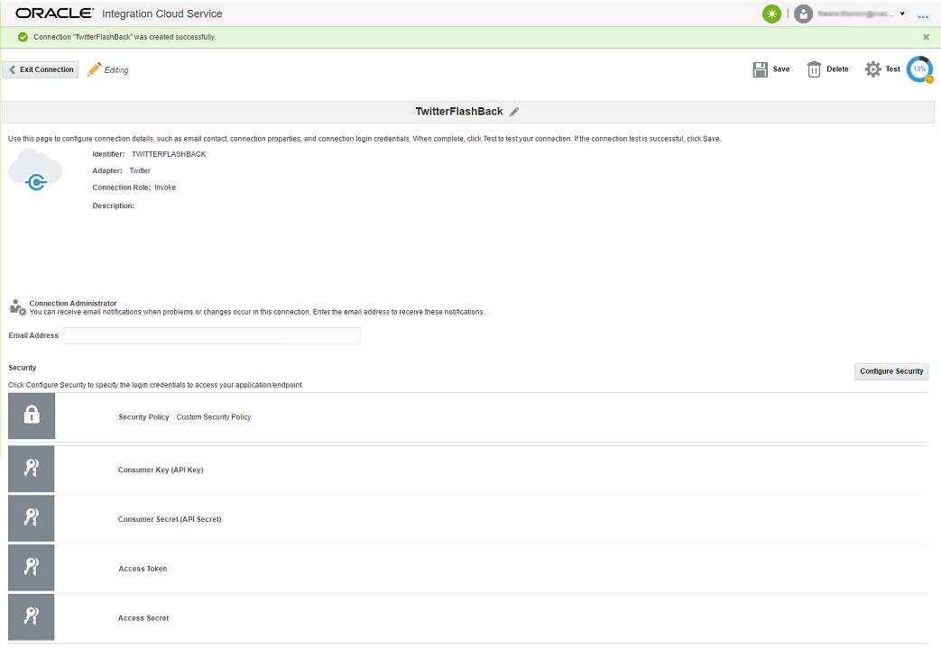

Click **Configure Security** button in the page, following dialog will appear to let you input credential information to establish the Twitter connection.

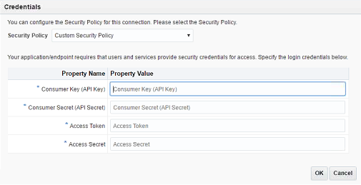

All credential information used in this dialog is from previous step. You can copy those parameters from Twitter Application Management page directly. After fill all required fields, click **OK** button.

Now all required parameters have been configured for the Twitter connection. However it is not sure that the connection will work. Click **Test** action on top of the page to trigger a test. If the test passed, a message will display in the light-green banner. Also the progress icon on the right will indicate that the connection is 100 percent correct.

After test is done, you can save the connection by clicking **Save** action. Then click **Exit Connection** action to go back to Connection Designer page.

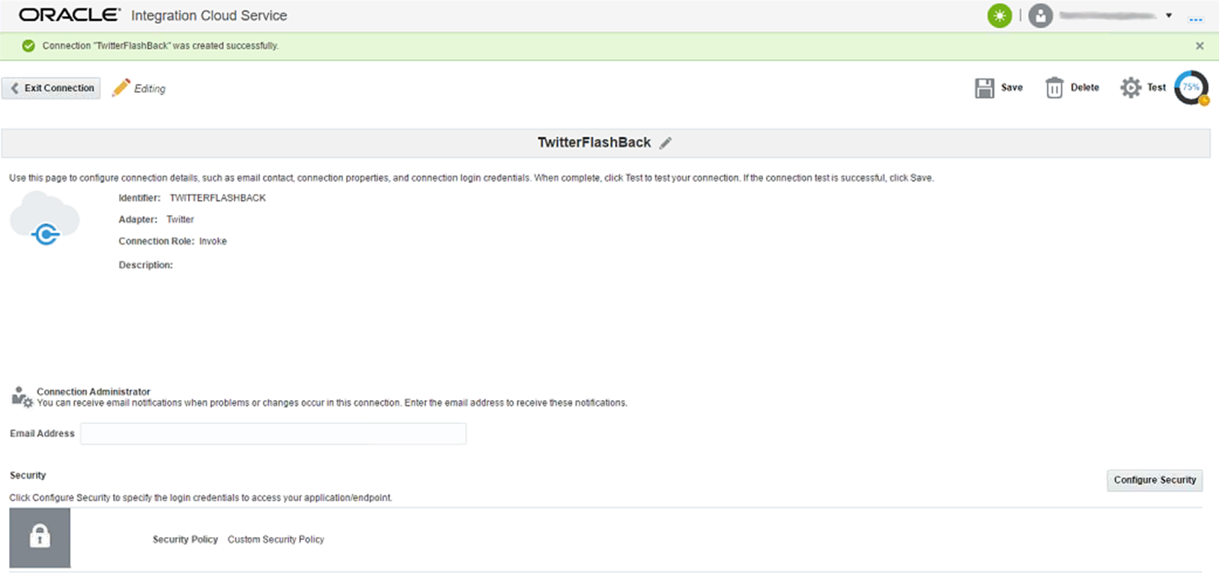

**2.2 Configure connection to Oracle Storage Cloud Service**

In the Connection Designer page, click **New Connection** action to launch the Adapter Selection dialog. Oracle Integration Service does not provide built-in adapter for Oracle Storage Cloud Service, however user can leverage generic REST adapter to access REST API endpoint of the Oracle Storage Cloud.

In the search box of the dialog, input “REST” then click the search icon, the REST adapter will be the only available adapter in the list.

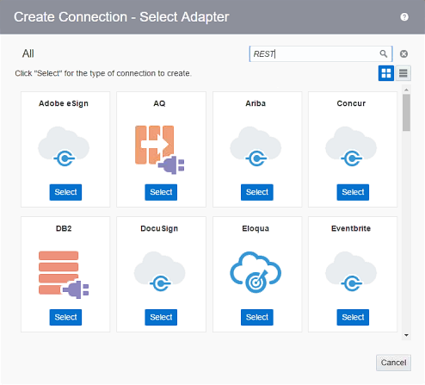

Click **Select** action in the REST adapter, the connection design page will show again to let you configure the connection to Oracle Storage Cloud Service.

First, following dialog will appear to collect general information of the connection.

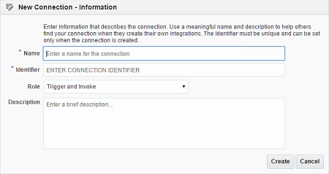

Specify the name of the connection and select **Role** to **Trigger and Invoke** which means that the connection can both receive notification from Oracle Storage Cloud when Object Store is changed and make requests to the Oracle Storage Service. Click **Create** button to create the connection.

Next, we need to input the connection parameters to REST API endpoint of the Oracle Storage Cloud. Click **Configure Connectivity** button in the page to launch following dialog.

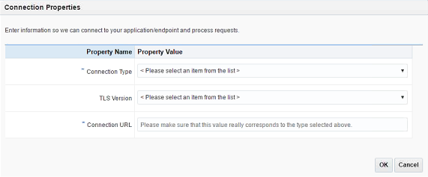

Set **Connection Type** to “REST API Base URL”, select **TLS Version** to “TLS V1.1” and copy the base url (without URI part) of the REST API endpoint of the Storage Cloud to the **Connection URL** field. Click **OK** to close the dialog.

The last parameters need to configure is the security information to login to REST API endpoint of the Storage Cloud. Click **Configure Security** button in the page to launch following dialog.

All the information in this dialog can be known from the Oracle Storage Cloud configuration. Format of the **Username** filed is “*Storage-<Identity Domain>:<login name>*”.

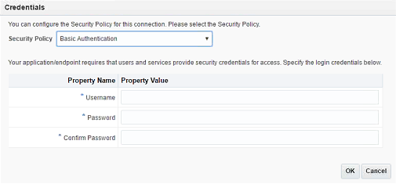

After specifying all required information, click **OK** to close the dialog.

Now all required parameters have been configured for the Oracle Storage Cloud connection. A test is also required to ensure the configuration is correct. After test is done, click **Save** action to save the connection, and then click **Exit Connection** action to return to Connection Design page.

**Step 3: Design the Integration**

In this step, we will demonstrate how to design integrations with Oracle Integration Cloud Service to load Twitter feeds that the user is interested in and pull the data into Data Lake in Oracle Storage Cloud.

Oracle Integration Cloud Service provides an interactive tool for designing integrations with zero coding. The tool is available from the Designer Portal in Oracle Integration Cloud Service page. To go to Designer Portal, select **Designer** link on top of the Oracle Integration Cloud Service page.

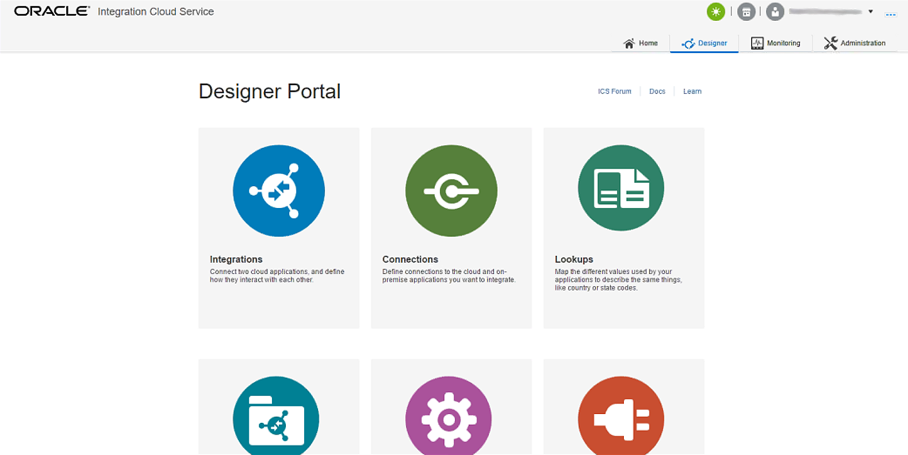

From Designer Portal user can go directly to various designer tools, for example Integration Designer, Connection Designer etc., in Oracle Integration Cloud Service. Click **Integrations** icon to launch following Integration Designer.

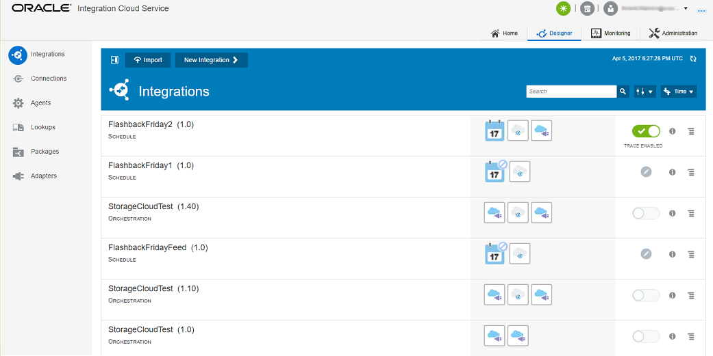

User can manage and monitor integrations in the designer page. To create a new integration, click **New Integration** button on the top. Oracle Integration Cloud Service has pre-defined styles or patterns to design the integration.

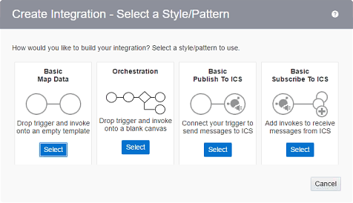

In this demo, the integration is complex. It needs to handle connections to both Twitter and Oracle Storage Cloud carefully. User also needs to control data ingestion, transform and output at fine-grained level.

Select the **Orchestration** pattern for the integration, following dialog will pop up to allow user provide general information of the integration.

Name, version and an optional package are used to uniquely identify the integration. An integration could be triggered either by an event from a service connection or a schedule defined by Oracle Integration platform.

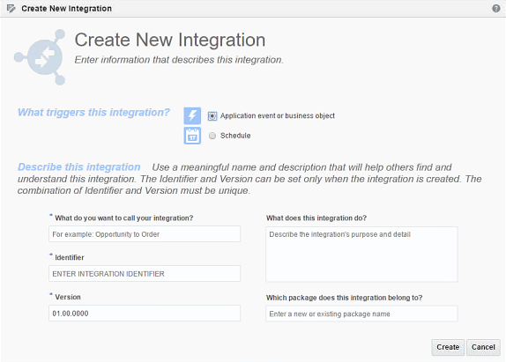

Select **Schedule** as trigger for the integration, and specify name, version and package for the integration, then click **Create** button.

Following Designer page will appear to give user an interactive interface to design logic of the integration. On the left of the page are popup toolboxes. User can select to **Invoke** an available services, add an **Action** and handle **Error** in the integration. In the middle of the page are panel to view and edit the integration interactively. If the integration logic is very complex, user can also zoom and go to different part of the view with UI controls in the page.

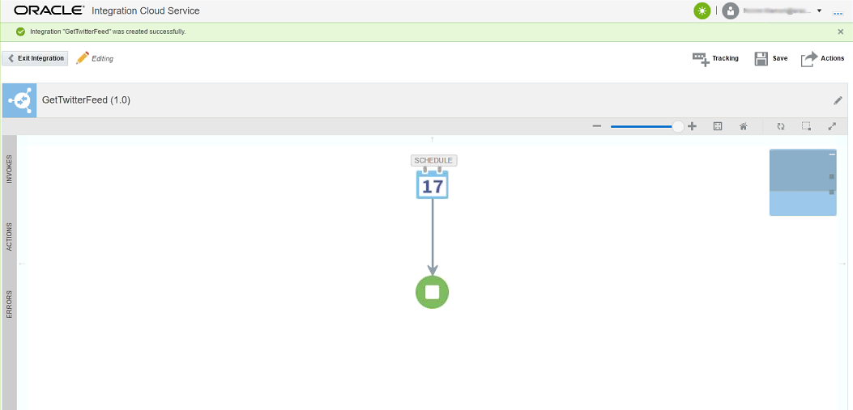

At initial, only a start and end node in the integration design page. User needs to add more logic to the integration.

In the demo, we will first invoke Twitter to retrieve any new feeds. Move the mouse to INVOKES tab on the left, it will pop up a toolbox to let user select available services. Select Twitter catalog, all Twitter service connections will show just below the catalog.

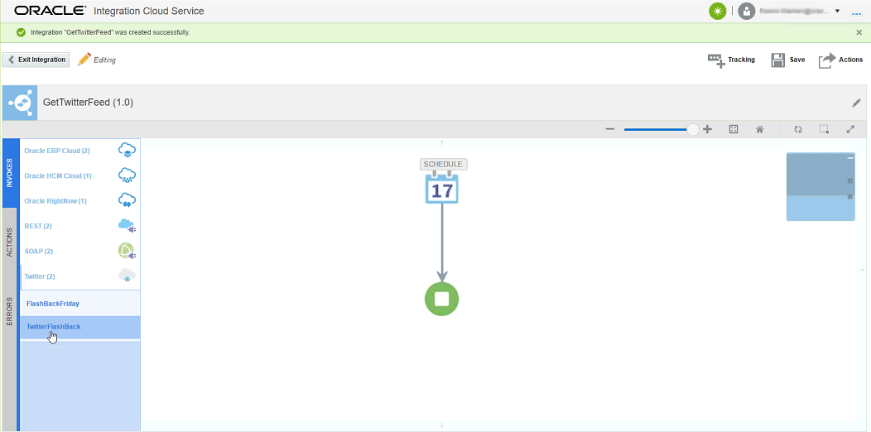

Drag the connection in between start and end node of the flow in the design panel.

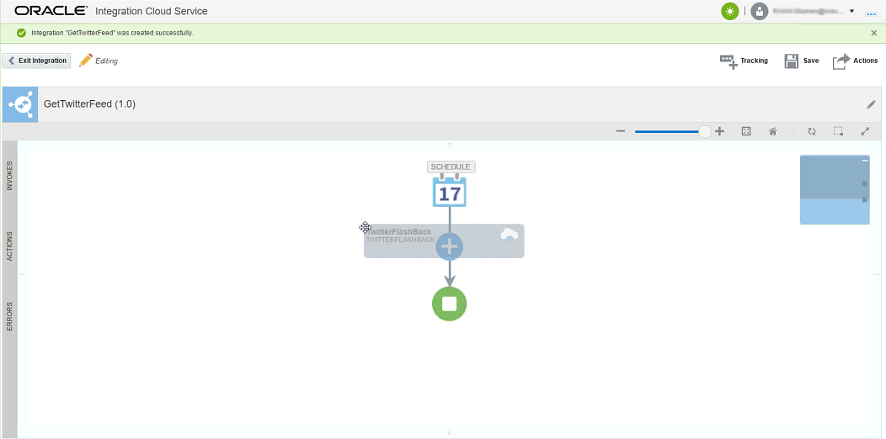

Following wizard will appear to let use customize the service invocation. The **Basic Info** tab let user assign a name of the invocation. The name will show as display name of the invocation node in the design panel.

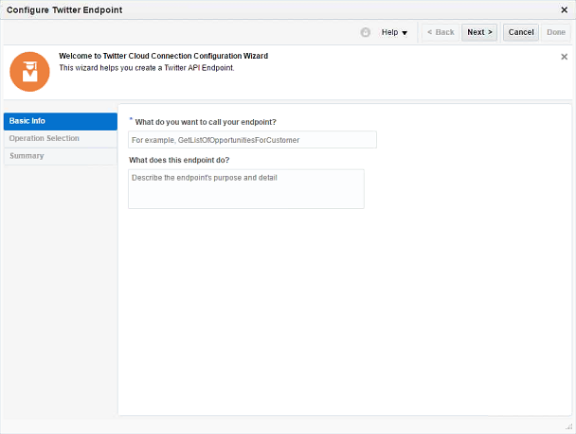

After filling the required information, click **Next** button to move to following page. In this page user can select which service function need to invoke from the integration.

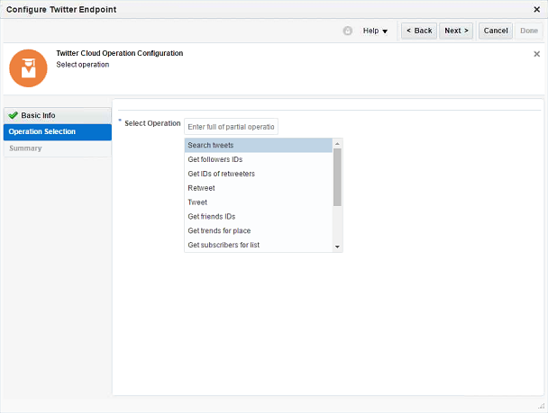

Select “Search tweets” from the function list, then click **Next** button to move to following page. This page will show overview information of the invocation. User has the opportunity to check the configuration, if anything is wrong, they can go back to previous page to make modification.

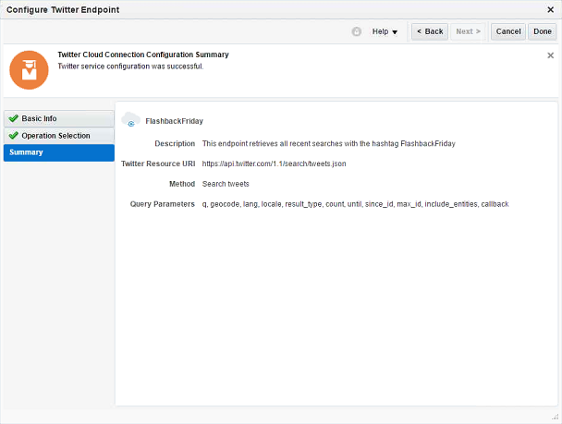

Click **Done** to accept the configuration. A new invocation node will appear in the design panel. However it is not done yet, user also needs to customize parameters of the invocation. Click the invocation node, a pop up toolbox will appear.

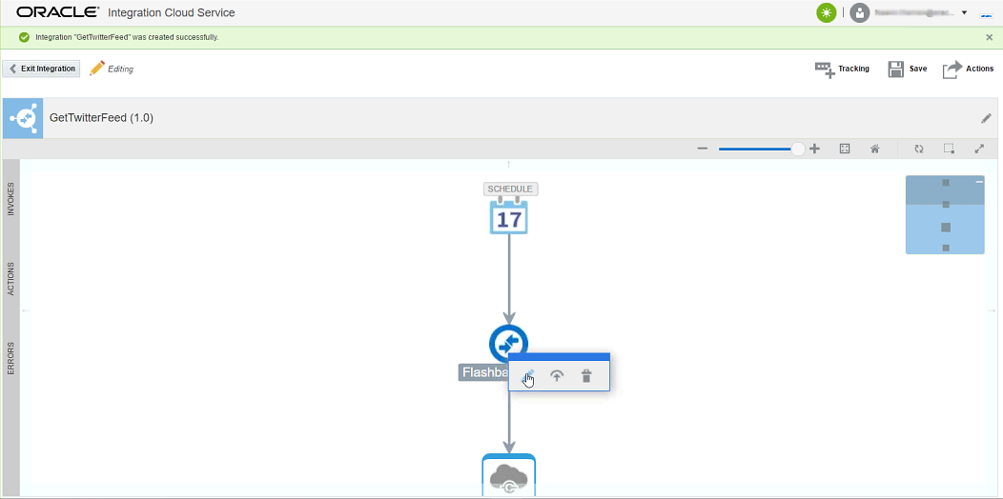

Click  button in the toolbox to launch following dialog to map invocation parameters. Available parameters of the service call are listed on the right. User can design mapping for each individual parameter. A mapping is the way to assign runtime value of the target of existing sources. The source could be a static value, data from an available data source etc. Click a parameter in the list can modify the mapping.

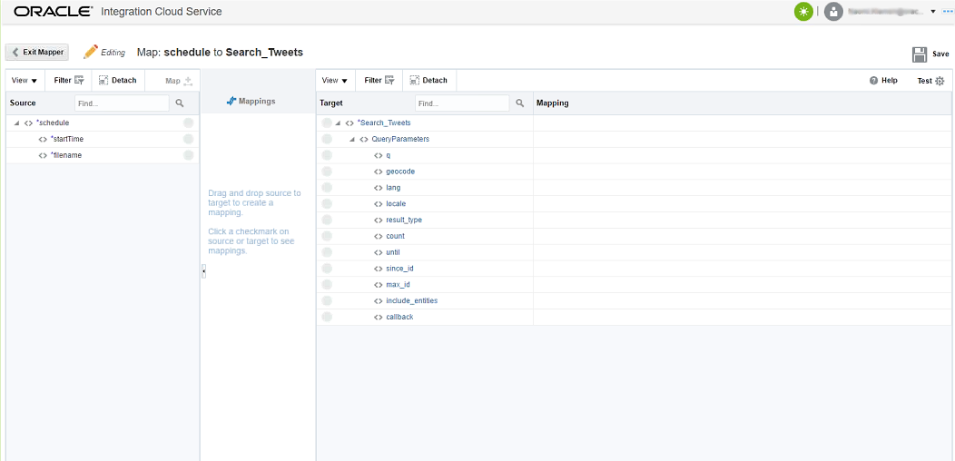

The first parameter needs to customize in the demo is **q**. Click the parameter will launch another dialog to design the mapping. User can select an entity from a source on the left, and drag it to link with the target. Also user can assign a fixed value to the target.

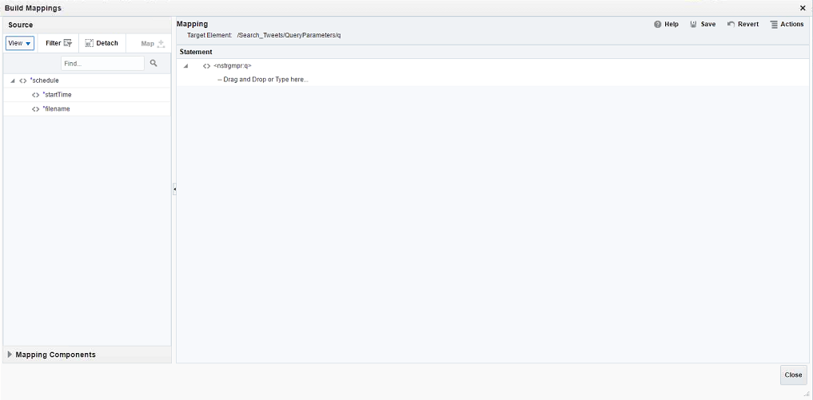

In this demo, the parameter will use a fixed value which indicates search tweets by a specific tag.

Click the target directly, a text box will appear to let you input the value. Input name of the interested tag in the tweets. You should encode the string according to XML standard.

Click **Save** button on the top to apply the change, then click **Close** button to return to previous dialog.

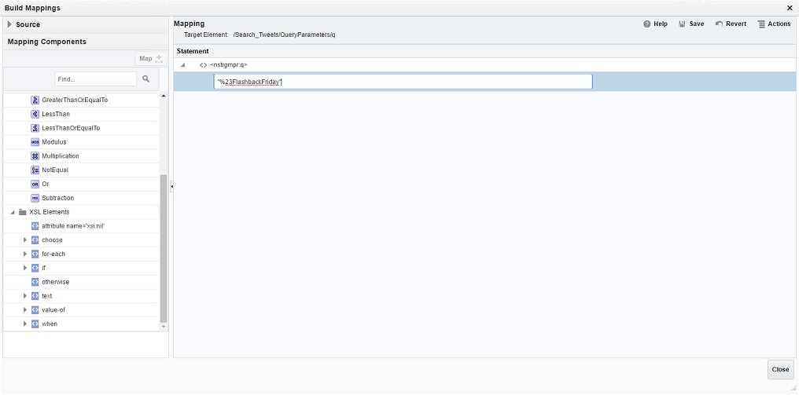

Another parameter needs to be customized is **result_type**. Use a fixed value “recent” for this parameter to only retrieve new tweets from user’s Twitter account.

After both parameters are customized, use can view the configuration in the dialog. If properly configured, click **Exit Mapper** button to save the change.

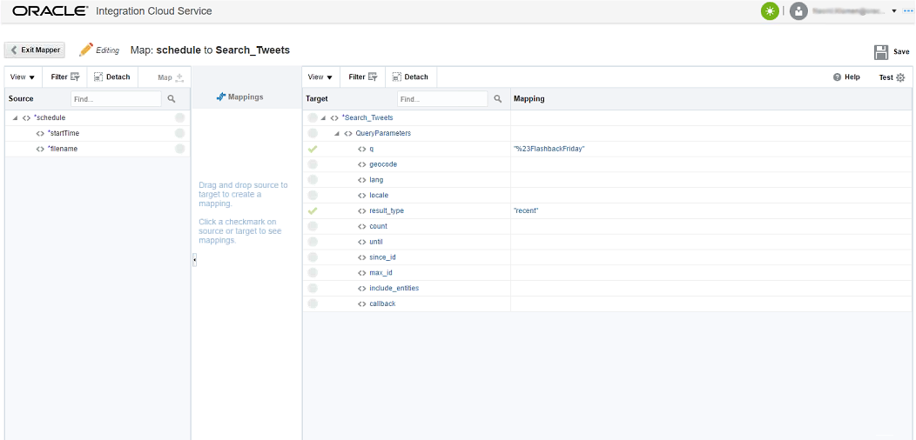

Now the integration can invoke Twitter to retrieve interested tweets from user’s account. Next step is to enable writing those tweets to Data Lake in Oracle Storage Cloud. Services from the Oracle Storage Cloud can be leveraged implement the function.

The integration will first authenticate to the Oracle Storage Cloud to retrieve a security token for following requests. Select pre-defined Oracle Storage Cloud connection from **INVOKES** pop up toolbox in the left. Then drag the connection to the position between the Twitter node and the end node in the flow.

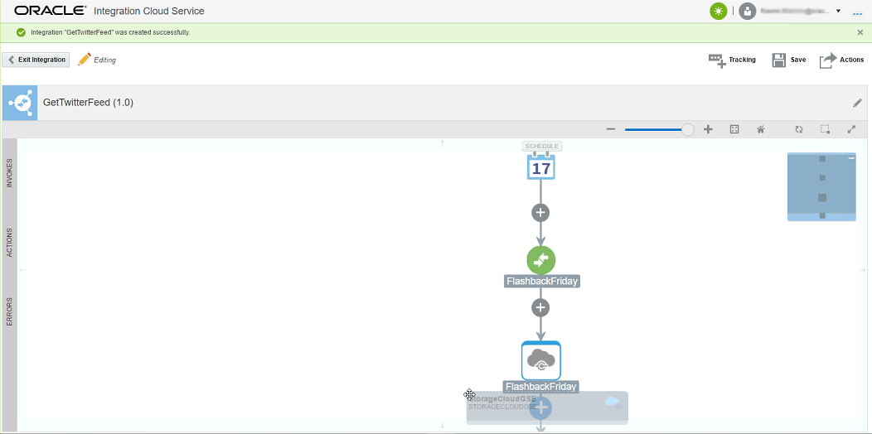

Following dialog will appear to configure the service invocation. The REST service endpoint at Oracle Storage Cloud is a HTTP service. The authentication process is wrapped in HTTP communication. Credential information is wrapped in a HTTP GET request, server returns authentication result in the HTTP response.

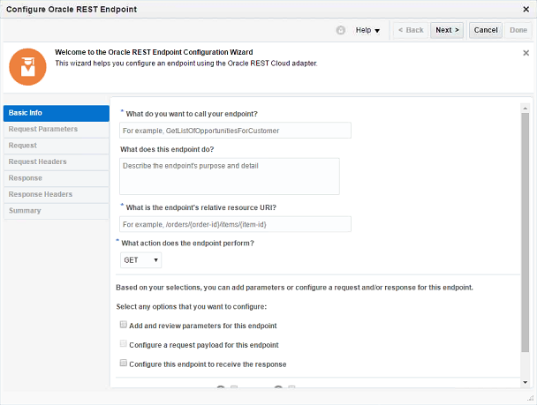

Specify the relative URI of the authentication service at the Oracle Storage Cloud, it is */auth/v1.0* in this demo. Select to use GET method to send HTTP request. Customization need to be enabled for both preparing Request headers and analyzing Response headers.

Click **Next** button to move to following page. The page allows configure HTTP headers that are specific to the authentication process. Click  button to add a new header declaration. A name must be given in left column and an optional description in right column.

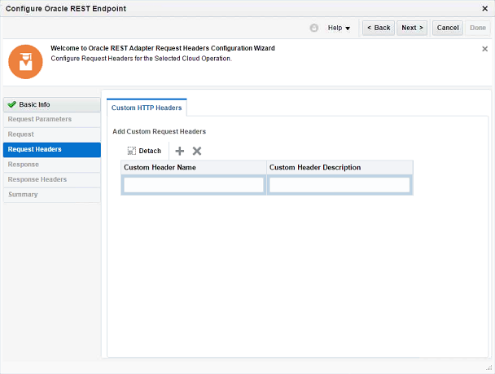

Two headers, **X-Storage-User** and **X-Storage-Pass**, are defined. They wrap username and password for authentication respectively.

After declaring both request headers, click **Next** button to move to following page. This page will declare response headers specific to the authentication process.

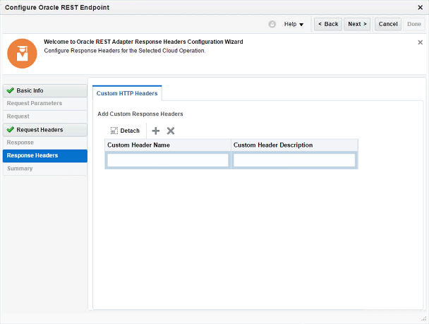

The response header **X-Auth-Token** is pre-defined to wrap the token if authentication succeeds.

After declaring the header click **Next** to move to following page. User can check the configuration in the page. If all configurations are correct, click **Done** button to commit the configuration.

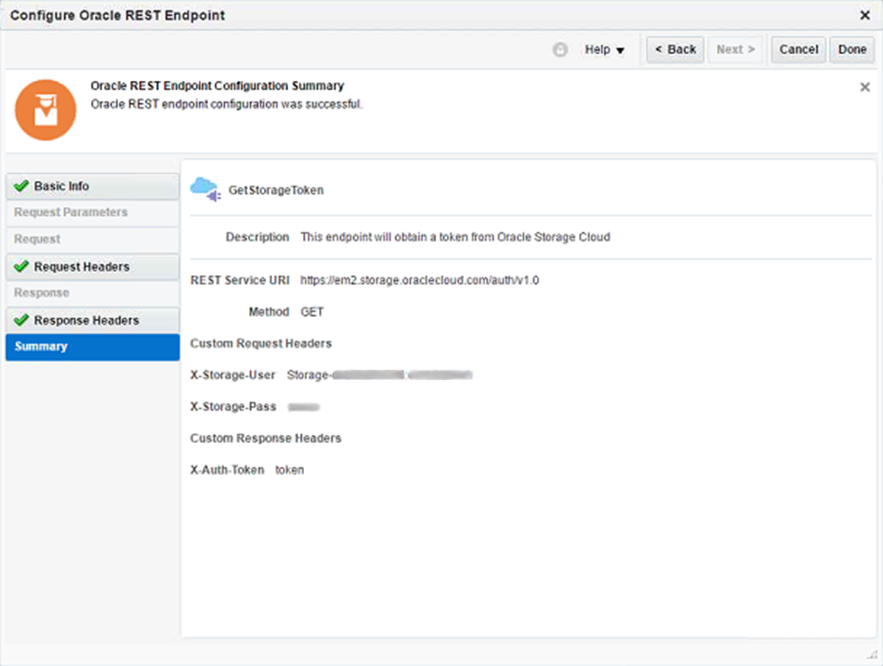

Next, we will provide value for parameters (request headers) in the request. Select the invocation node and click  button in the pop up toolbox to launch the Mapper dialog.

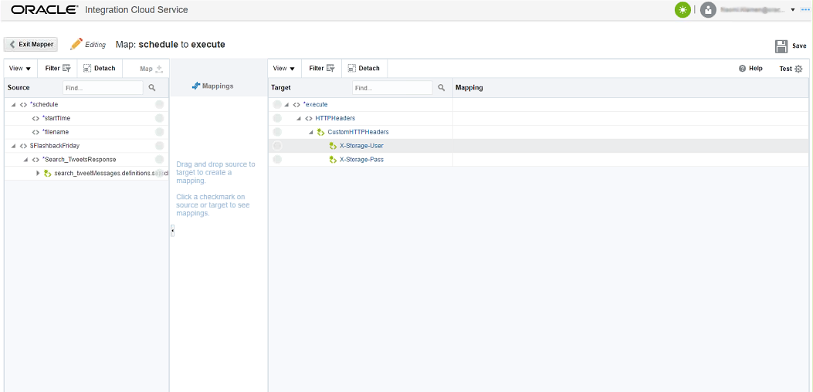

Click each HTTP header declared previously. In the demo, we will use static value for both headers. Values for both headers are from Oracle Storage Cloud configuration. Format for X-Storage-User is “*Storage-<identity domain>:<login name>*”.

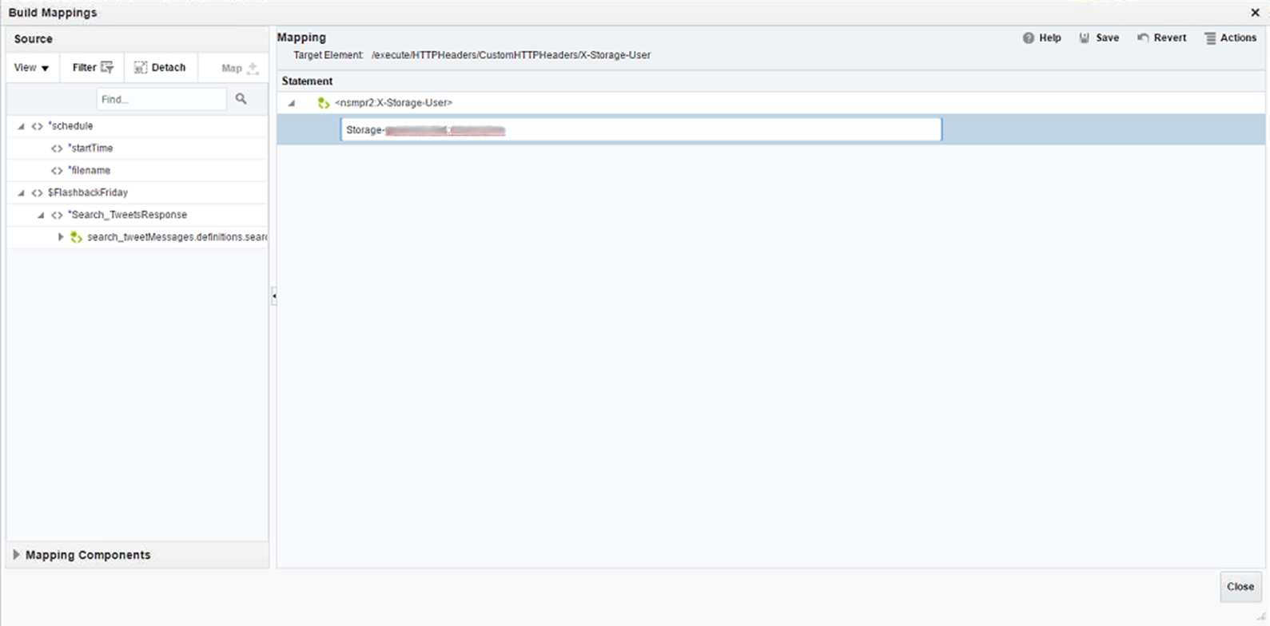

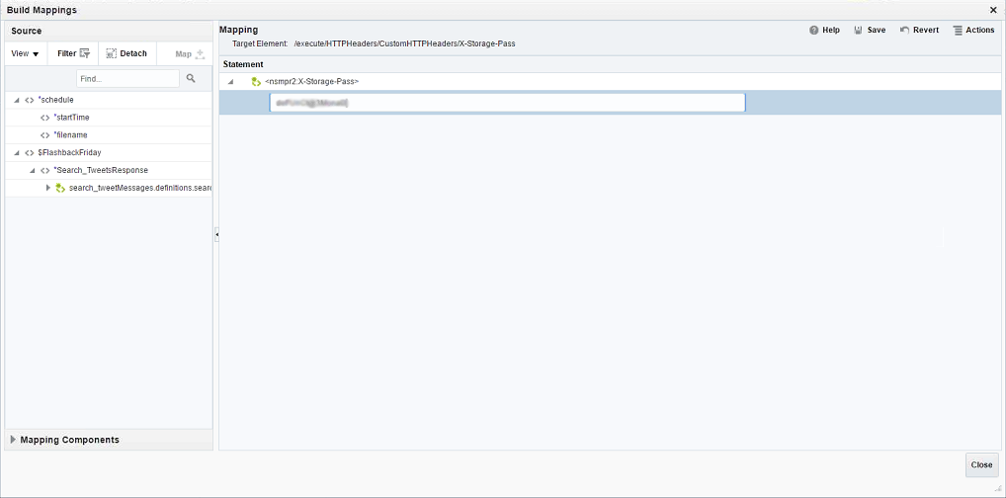

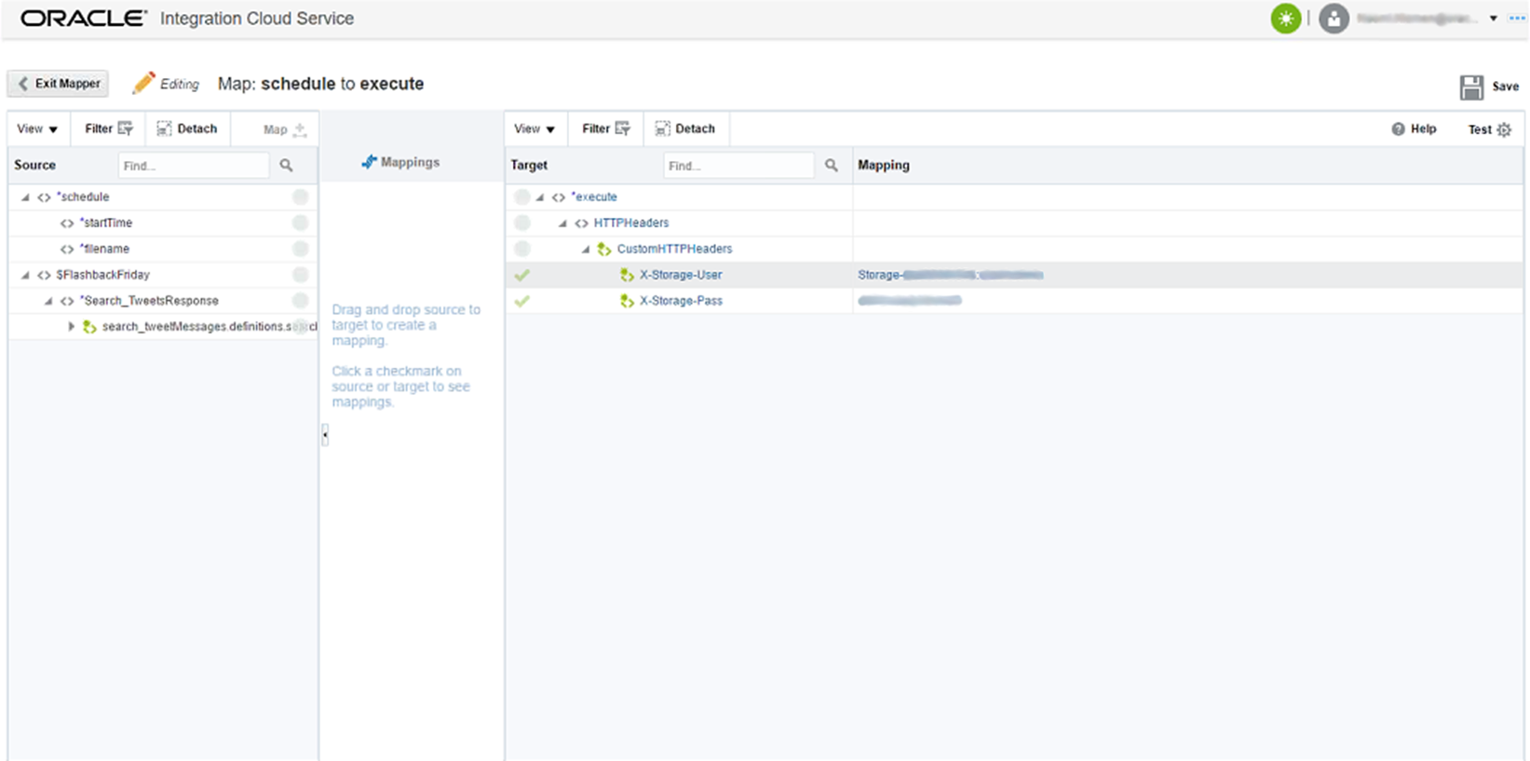

After committing the values, click **Exit Mapper** button to return to Integration Designer. Next action in the integration flow is to write data to Oracle Storage Cloud.

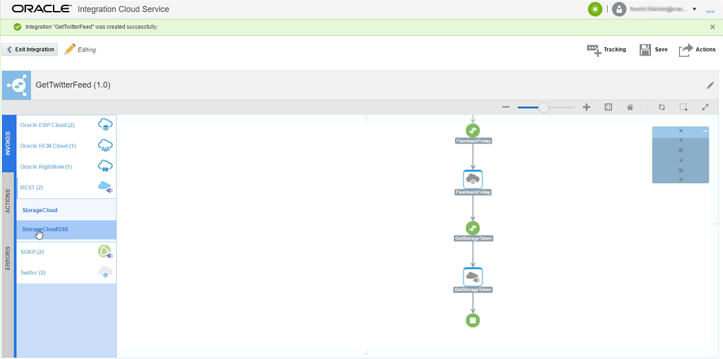

Select the Oracle Storage Cloud connection from the INVOKES toolbox, and drag it between authentication result node and end node in the flow. Following dialog appears again to configure REST invocation.

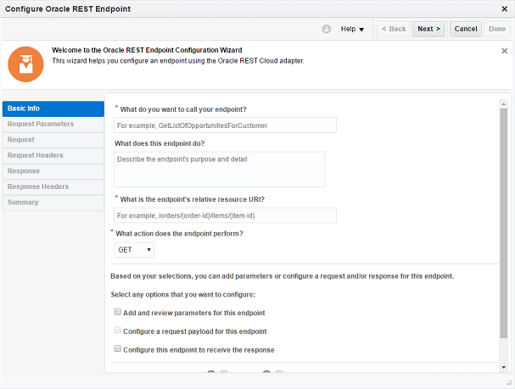

The URI for the data object upload service in Oracle Storage Cloud is in the format: */v1/Storage-<Identity Domain>/<Container>/<Object Name>*. The service leverages HTTP PUT method to upload the data object. Content of the data object is sent as payload in a HTTP request. **X-Auth-Token** header must be included in the HTTP request as the authentication proof to the service.

To enable the integration flow to control data object name at runtime, we use the template */v1/Storage-<Identity Domain>/<Container>/{Object Name}* for the service URL. The container must be created in advance before the demo.

Select **PUT** as the request method, and check **Configure a request payload for this endpoint** to enable payload customization. Also need to enable request header customization in order to append **X-Auth-Token** header in the request.

Click **Next** button to move to following page. User can add additional query parameters for the URI.

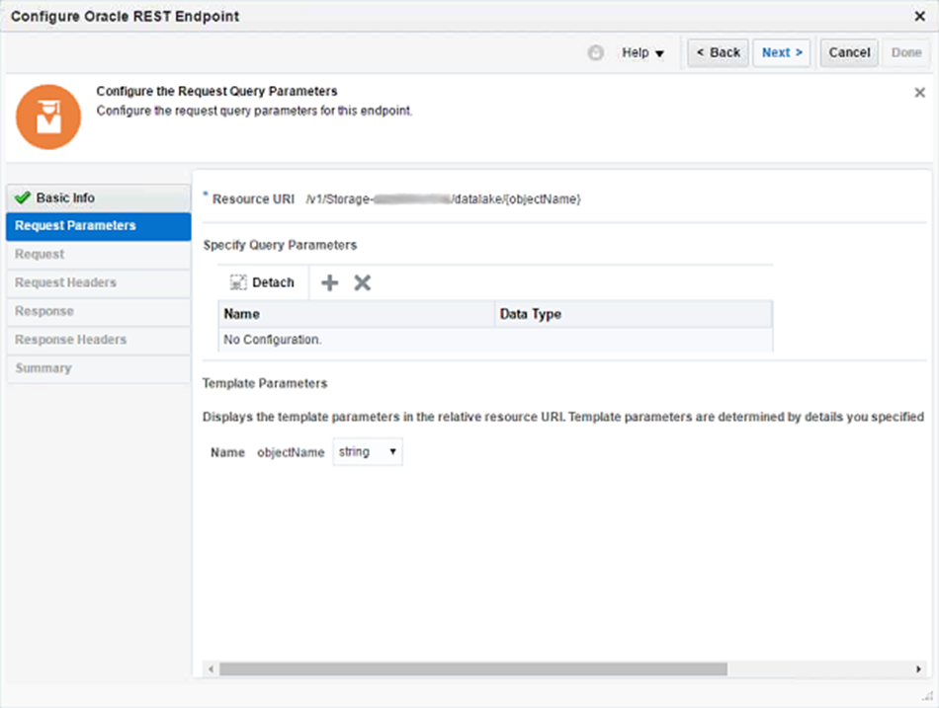

However, there is no query parameter defined for the service. So simply click **Next** button to move to the following page.

In the page, user needs to customize format of the payload. First, user need to select type of the payload. For different payload type, there are different ways to describe the format. For example, user can select an XSD schema file as format for a XML-based payload. Integration Platform will parse the format selected in the page to build data object at runtime.

In the demo, payload of the request is in XML format. A XSD schema file has been created to describe the XML document architecture.

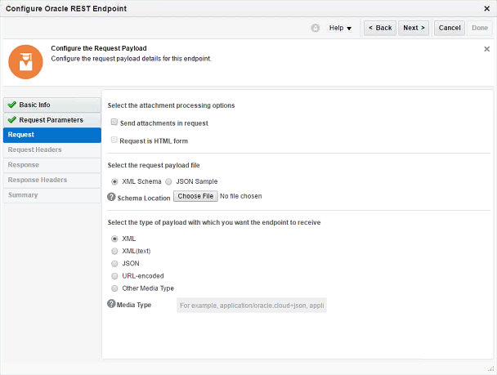

Select XML as type of payload and also upload the XSD schema file. Then click **Next** button to following page.

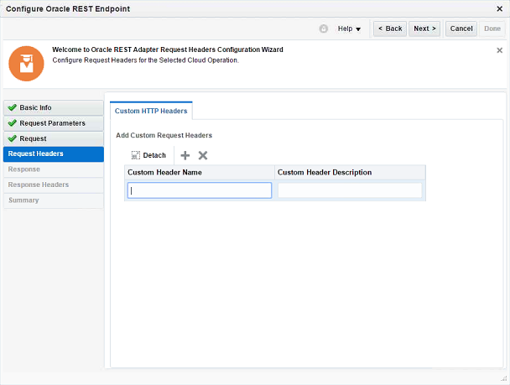

Add **X-Auth-Token** as a required HTTP header in the request. The exact value of the header will map the security token returned from the previous step.

Click **Next** button to the **Summary** page to check your configuration. If everything looks OK, click **Done** button to commit the invocation.

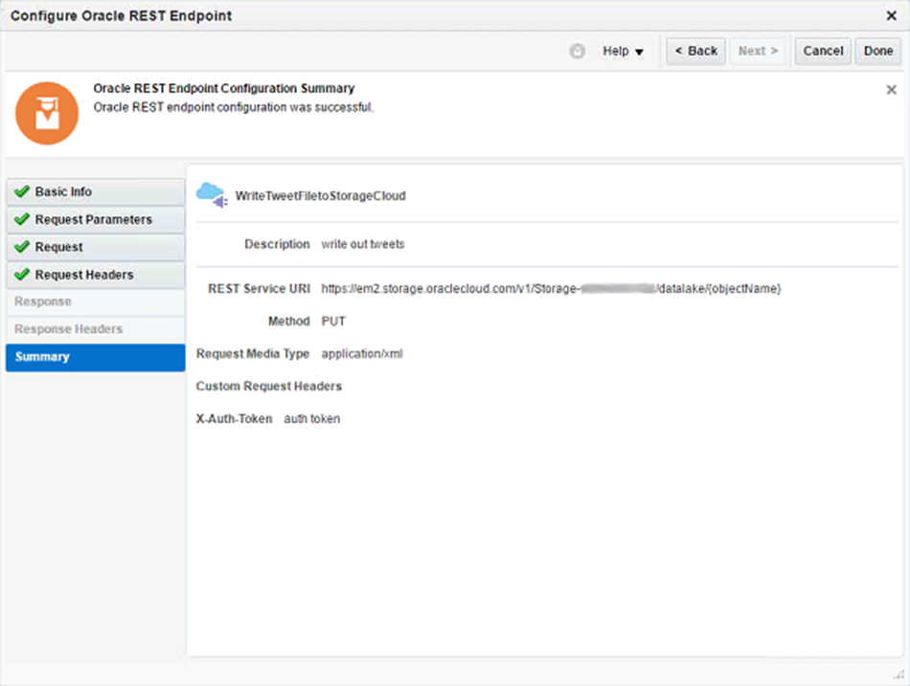

Next, we will customize mapping for parameters in the invocation. Click invocation node in the flow and click  button in the pop up toolbox to launch following Mapper dialog.

The first parameter is **X-Auth-Token** header in the HTTP request. The value for the request header should be identical as the token returned from the authentication action.

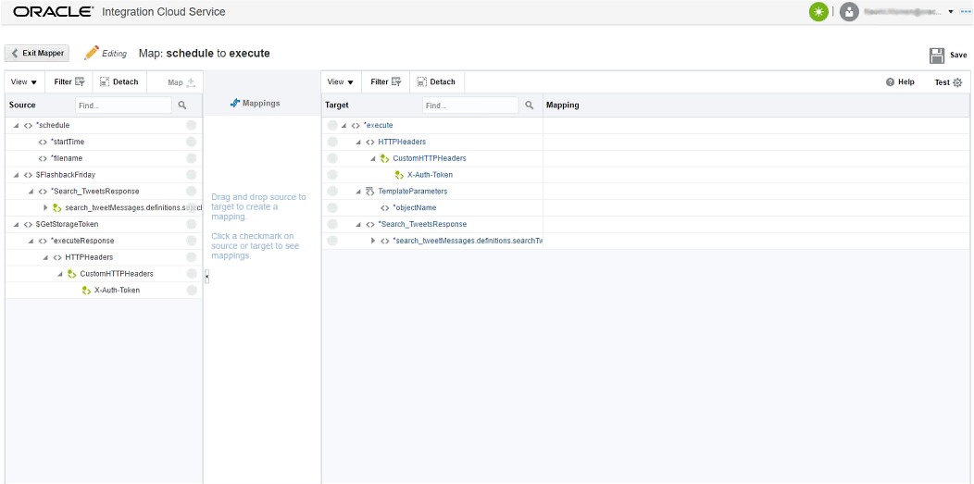

The result of invocation to authenticate to Oracle Storage Cloud is a source in the left. Collapse the source to find the custom response header **X-Auth-Token**, and then drag it to the **X-Auth-Token** header as target in the right. A link is established between the source and target as below.

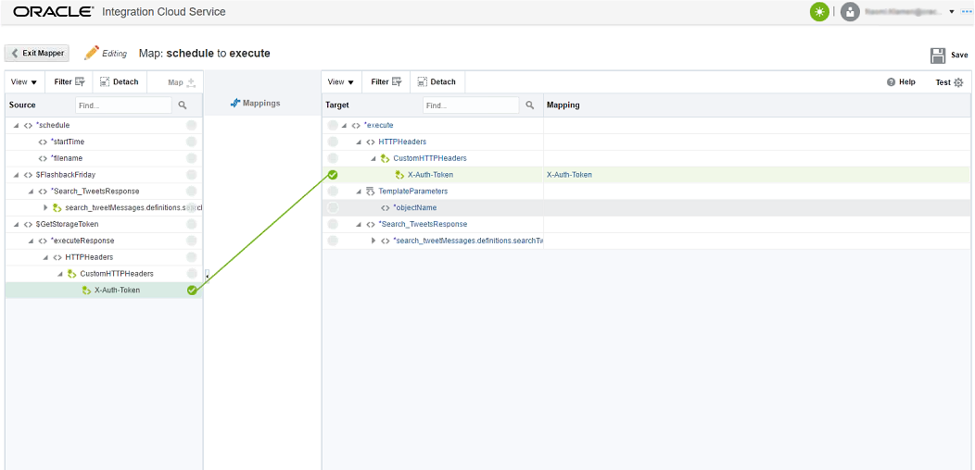

Next parameter must be customized is **objectName** in the URI template. It will dominate name of the data object in Oracle Storage Cloud. Click the parameter to launch following Mapping dialog.

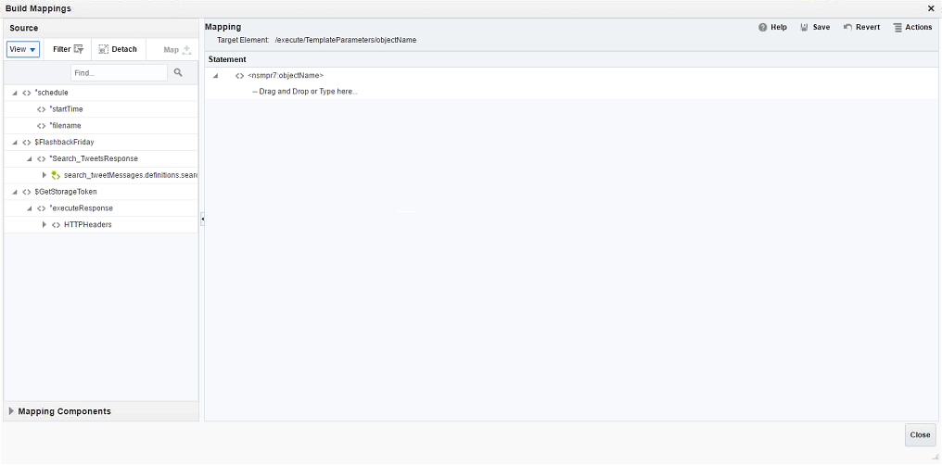

In the demo, current date will be used as name of the data object. To get value of current date, we will use pre-defined function in the Integration platform.

Function is a kind of Mapping Component which is defined to return a value. All available functions can be selected from Mapping Components catalog in the left.

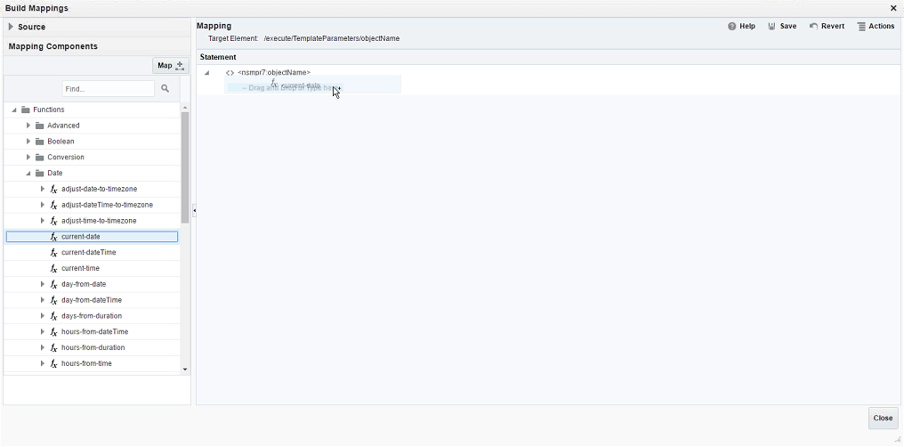

Select **Mapping Components** catalog in the left, locate the **current-date** function from the *Functions -> Date* path. Drag the function to the target parameter on the right. Following page will indicate that the parameter will use the function to retrieve current date as name of the data object.

Click **Save** action, then click **Close** button to save the mapping.

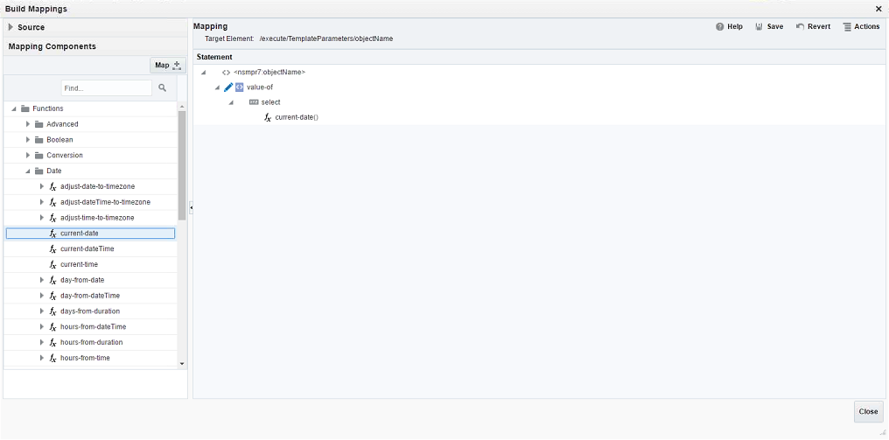

The last parameter in the invocation is the payload in the request. In the demo, the payload will be generated from the result retrieved from Twitter previously. The result of that invocation is a XML document too. So the standard and easiest way is to transform the document into the payload with a XSL template.

To make the demo simpler, we use same schema for the payload as that for the retrieved tweets. The XSL template only needs to iterate elements in the source document and generate elements with same name, with same number in the payload. All child elements are mapped one-to-one from source to target.

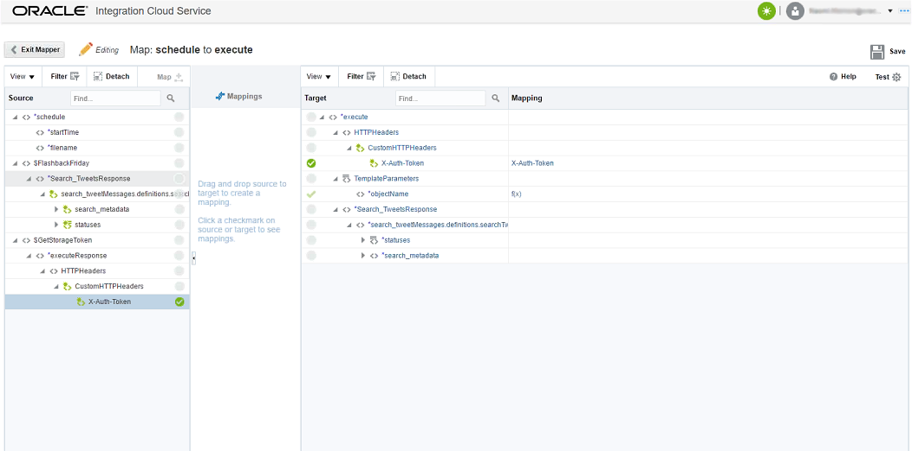

The Mapper Designer supports creating a XSL template interactively. In the schema tree, an element that can repeat more than once is decorated with an icon  ahead. Those elements are always starting point of the template design. In the demo, we will start from the “**statuses**” element. Click the element in the target schema tree will launch following dialog.

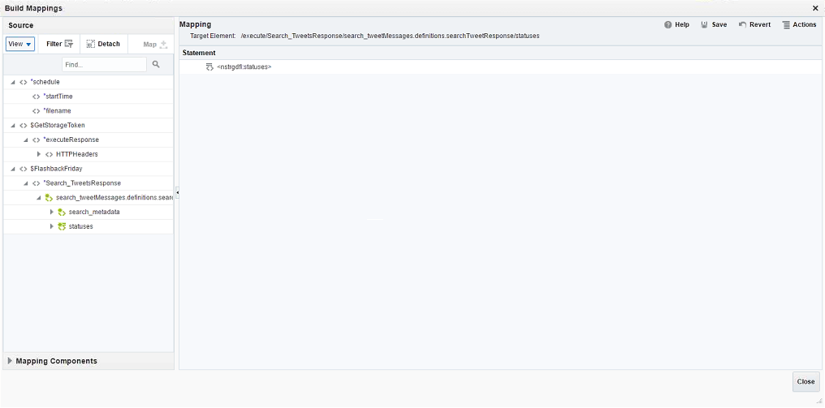

The transform process will iterate corresponding elements in the source document then generate elements in the target. To enable the iteration process, select the statement in the right, then click Actions button on the right-top of the dialog. Following menu will pop up.

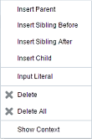

Select **Insert Parent** from the menu, an empty control is added as the parent.

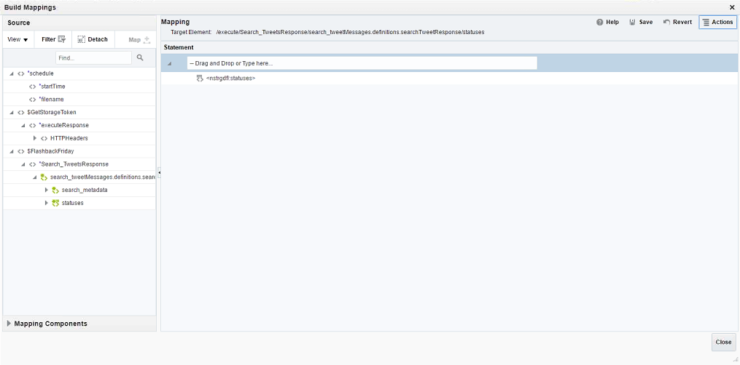

Next, you can add the iteration control to the parent statement. XSL Elements is a kind of Mapping Component in the tool. You can list available elements within **Mapping Components** catalog.

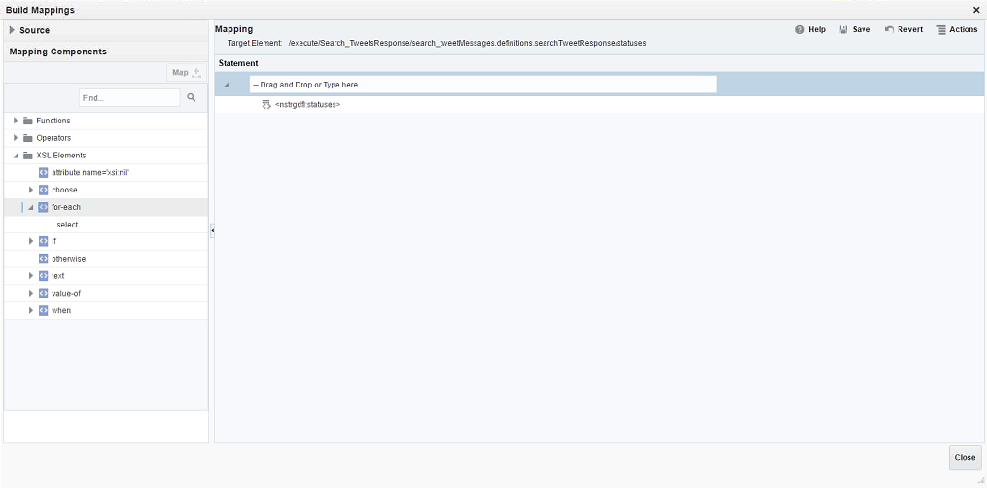

The **for-each** element is designed to iterate elements in a XML document. You can find it under the **XSL Elements** node. Drag and drop it onto the parent. The empty parent will be replaced by **for-each** element.

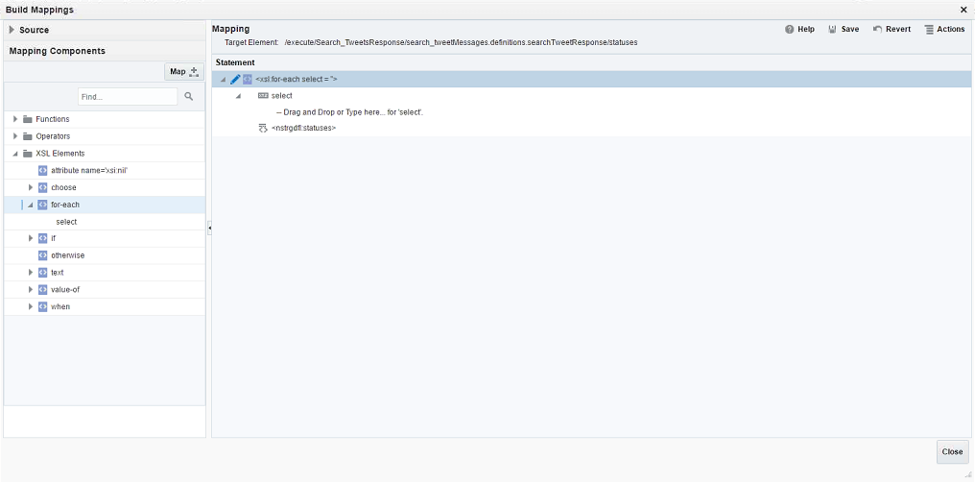

The **for-each** element requires a **select** attribute to specify name of the elements in the source document. User can map value of the attribute with an element in the schema of source document.

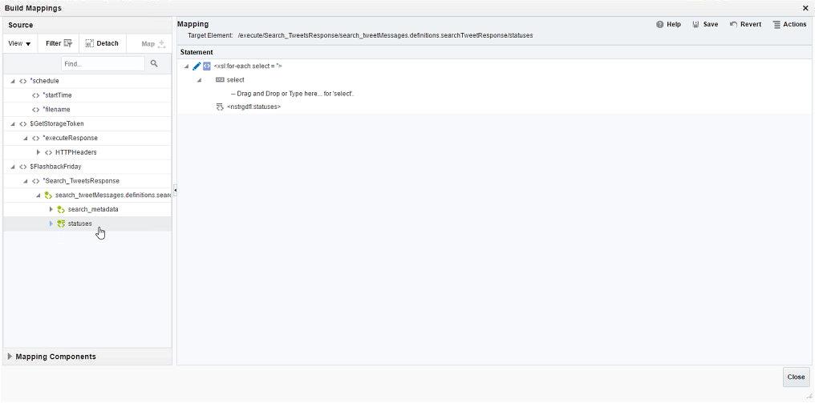

Find the source document schema from the **Source** catalog, and then locate the element that will be transformed to the target document. In this demo, it is the element with identical name. Drag and drop the **statuses** element to the **select** attribute under the **for-each** element in the right.

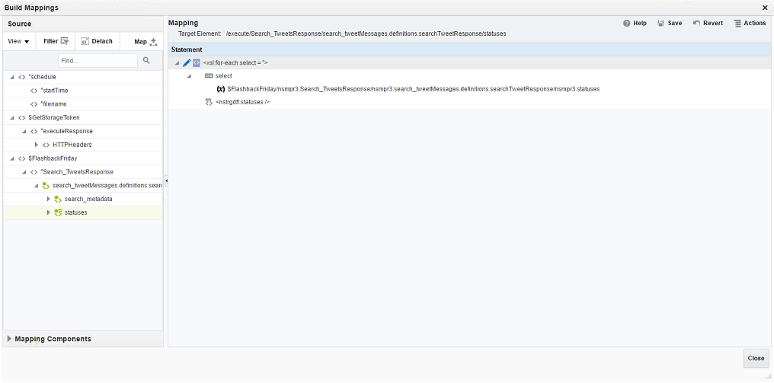

Click **Save** action on top of the dialog then click **Close** button and return to Mapper Designer page.

Next, we need to map child elements. Collapse the **statuses** element in the schema tree on both sides. All child elements are listed so that you can easily establish the map.

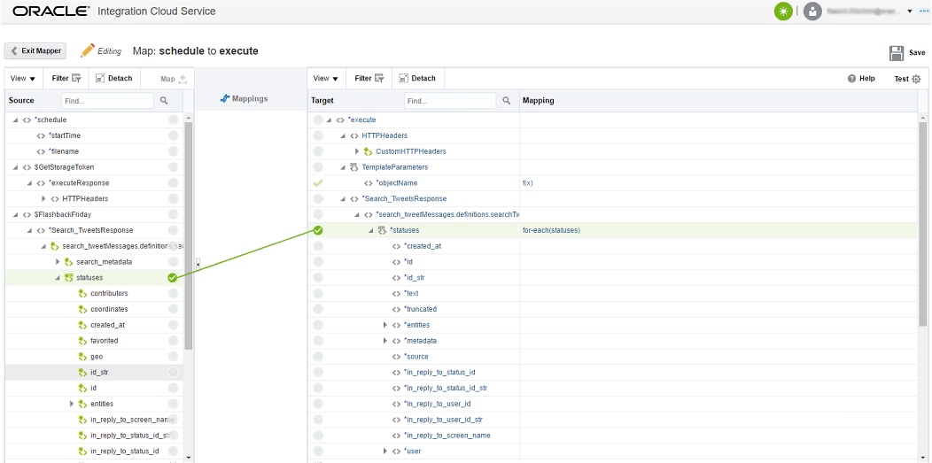

The mapping rules used in this demo include:

1. Map the elements with identical name between source and target.
2. Only need to map those elements you want them appear in target document.

To implement those rules, user can simply drag selected child elements in the source to the elements with identical name in the target.

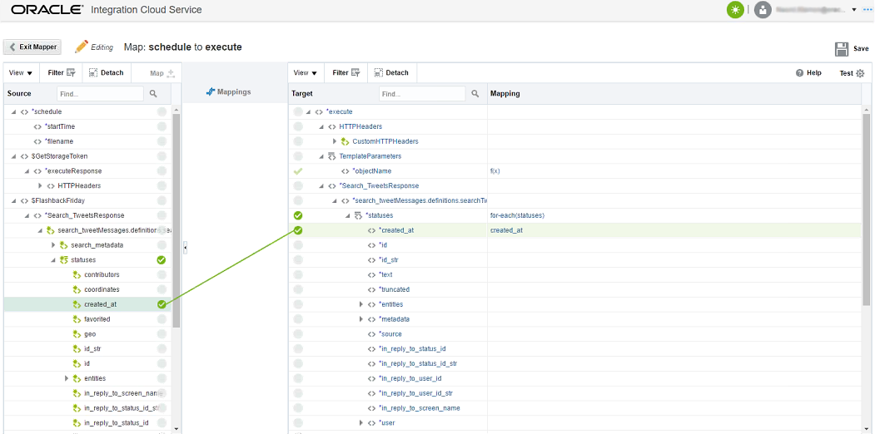

When required element mappings are done, click **Save** action to keep your modification safe. Then click **Exit Mapper** button and return to the Integration Designer.

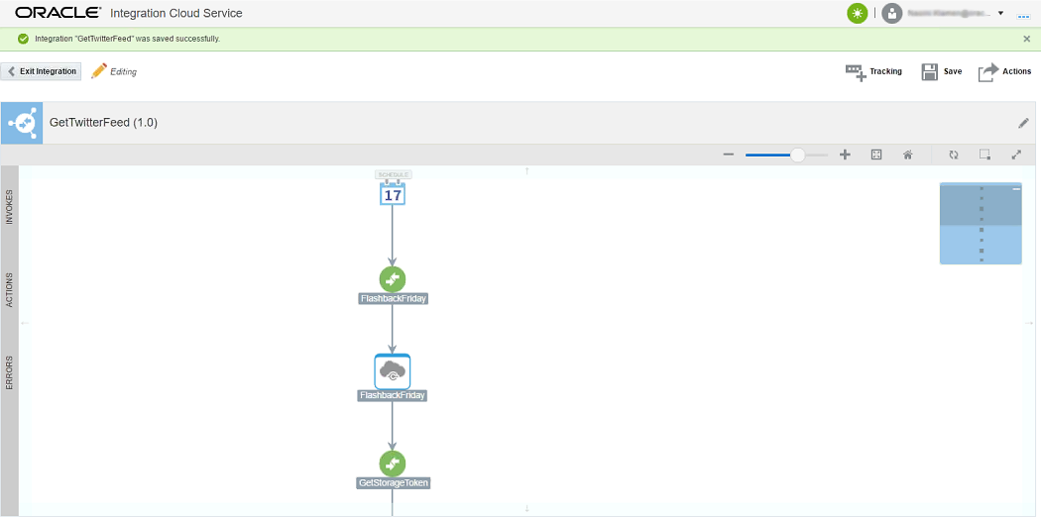

Now the integration flow is completed. User can further customize tracking for the integration. Tracking is a mechanism of Oracle Integration Cloud Service to enable administrators to identify a running integration. Tracking record is composed of information or business identifier from the running integration.

Click **Tracking** action in the upper right to launch following dialog to customize tracking for the integration. User can select up to three business identifiers available from the list in the left as tracking fields. One of them must be marked as primary tracking field.

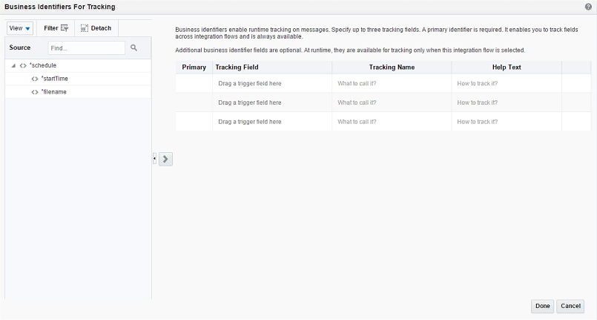

In this demo, we only rely on the time when the integration was launched to identify a running integration. Drag the schedule variable **startTime** from the left and drop it into Tracking Field column in the right, then click **Done** button in the dialog.

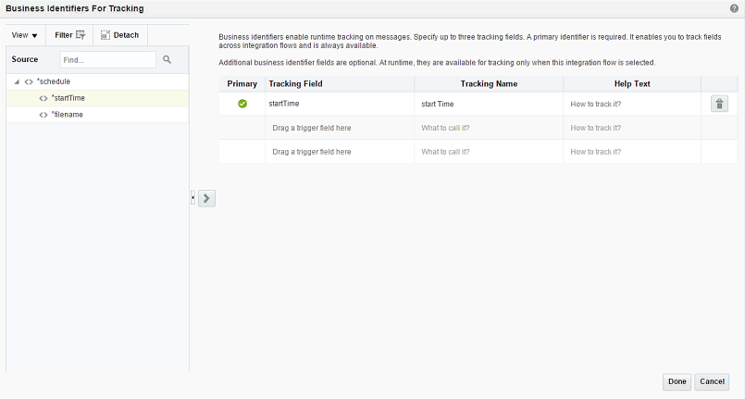

Congratulation, you have done all design efforts for the integration. Click **Save** action in the Integration Designer to save your work then click **Exit Integration** button.

**Step 4: Activate the Integration**

The integration is ready to run. In this step, we will demonstrate how to activate an integration and monitor it after execution.

**4.1 Activate an integration flow**

In the following page, find the integration we just created. You may notice that it is not activated yet.

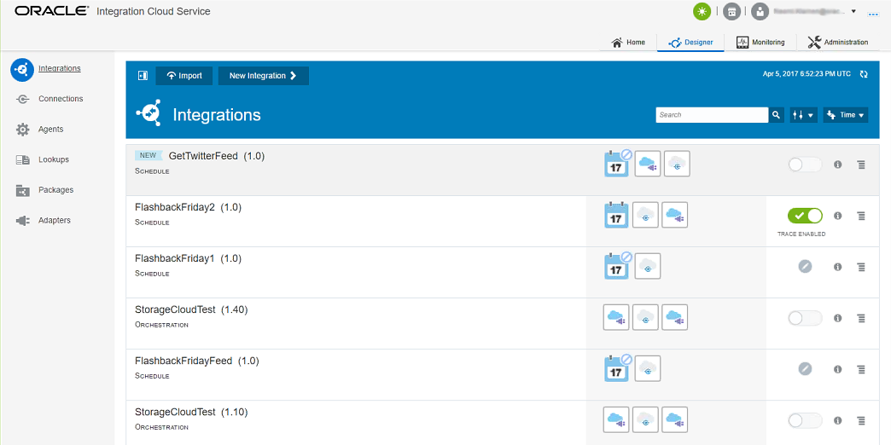

Click  button in the right of the integration, a menu as below will pop up. Select **Activate** item in the menu.

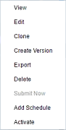

Following dialog will appear to let user control how the integration is activated.

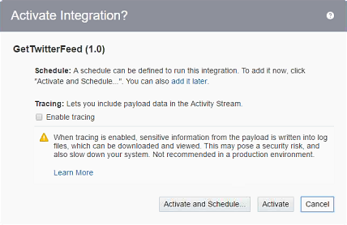

Click **Activate and Schedule…** button to schedule the integration right now. Following designer gives user additional control on the integration schedule.

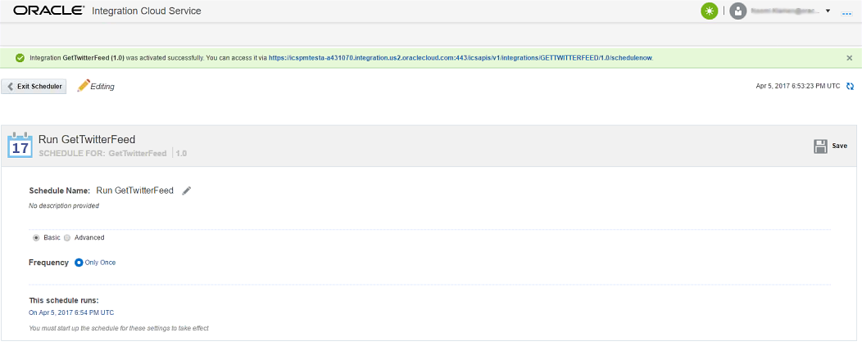

In this demo, we will customize **Frequency** of execution of the integration. From the drop-down menu you can see that the integration can be scheduled at fine-grained level.

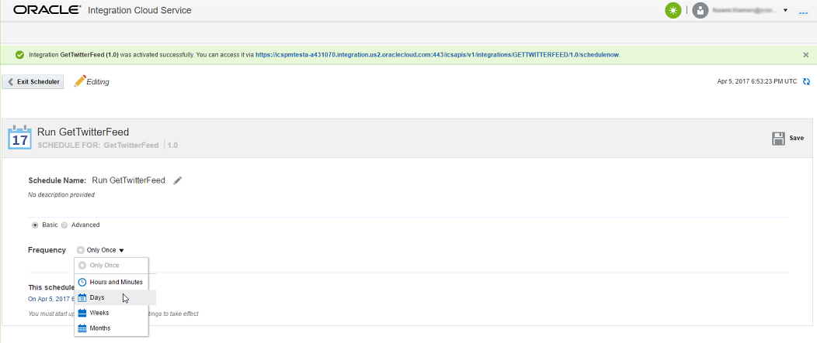

In this demo, select **Hours and Minutes** to schedule the integration repeatedly. Controls in the dialog as shown below let user customize the schedule.

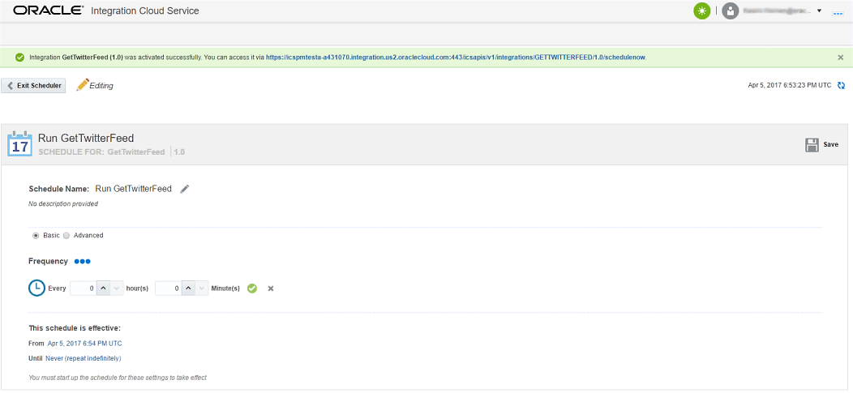

Increase the **hour(s)** field to 1 to schedule the integration every 1 hour. Click **Save** action in the upper right, then click **Exit Scheduler**. Following page will display and let user to review the schedule and decide when to submit the schedule.

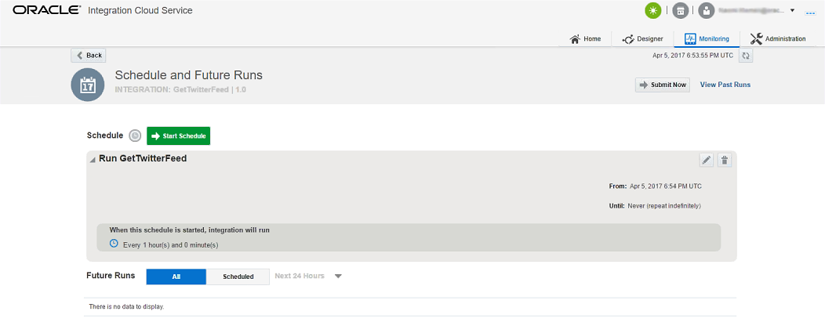

Click **Submit Now** button to schedule the integration immediately.

**4.2 Track and monitor an integration flow**

After the integration is scheduled, user can track and monitor the integration through Oracle Integration Cloud Service. All monitoring functions are consolidated in the following monitoring page. User can go to the page by clicking **Monitoring** link on the top.

The dashboard in the page will give user an overview of the whole Integration Service instance from workloads to performance. The panel on the left is a quick navigation to different monitoring functions.

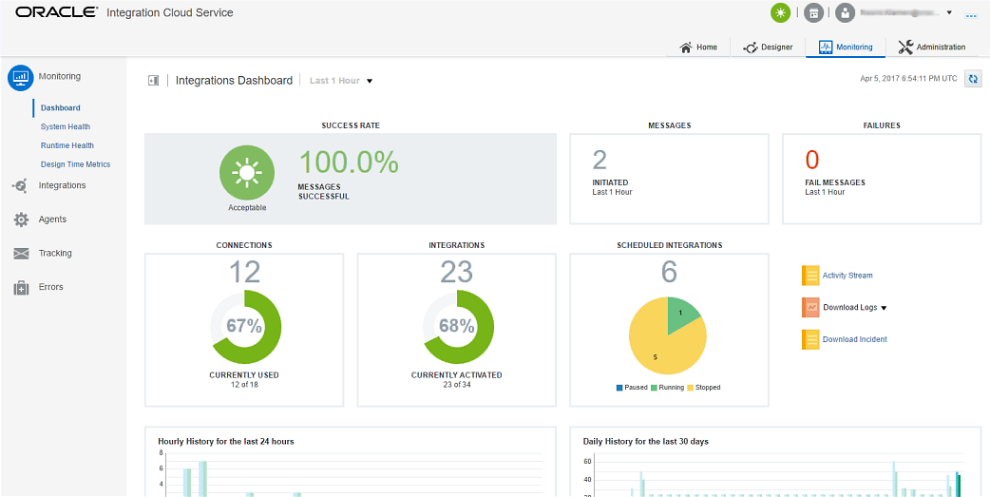

Select **Integrations** from the left panel will show following Integration Monitoring page. In the page, user can see clearly statistics of execution history of integrations.

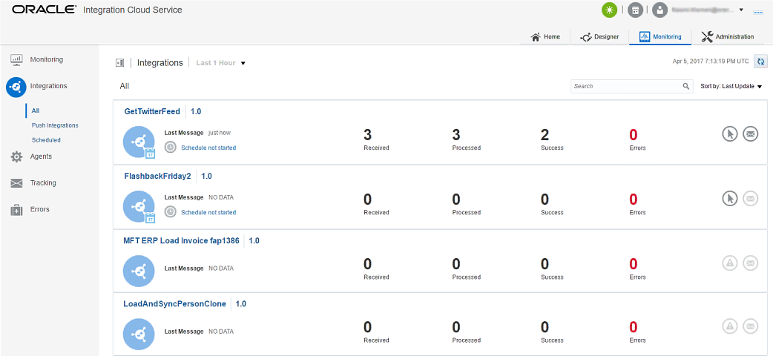

Select **Tracking** from the left panel will show following Integration Tracking page. In the page, user can see every scheduled execution of integrations. You may notice that the tracking fields you selected for integrations are displayed here. It helps users to uniquely identify an integration execution.

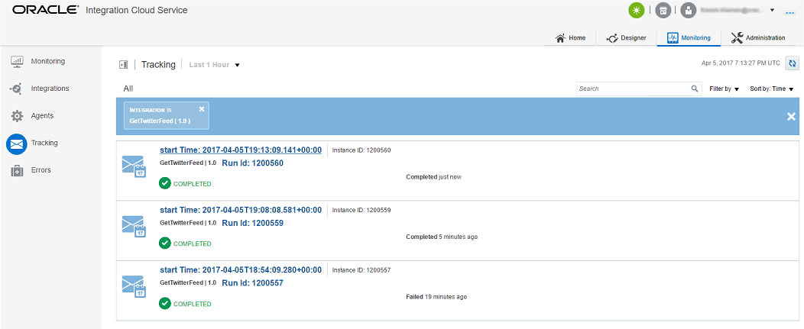

Click an integration execution in the list will jump to following page. User can view the progress and state of the integration flow.

